AWS Elastic Kubernetes Service.

Amazon EKS is a managed service that makes it easy for you to use Kubernetes on AWS without needing to install and operate your own Kubernetes control plane.

Step 1:-

* Log on to AWS and search AWS EKS service and go that service.
* 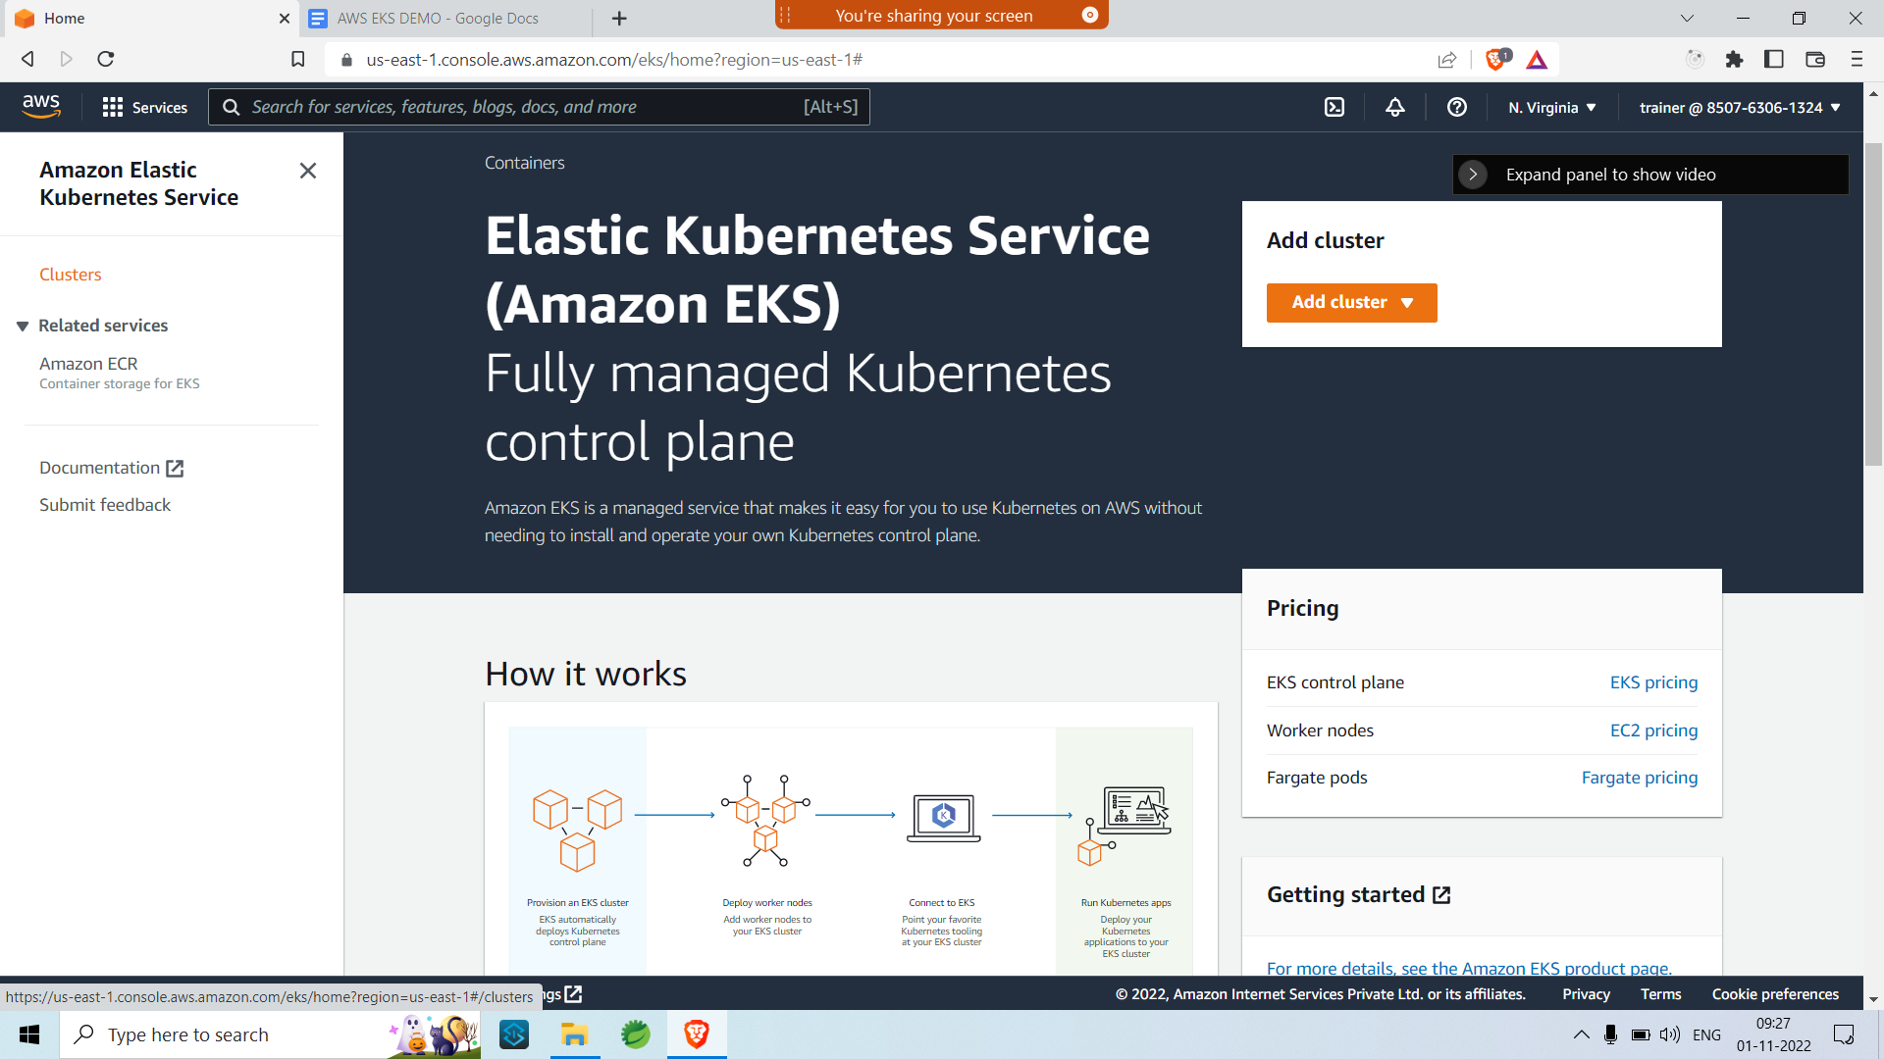
* Click on Clusters on the left side panel.
* Click on Add clusters button on the right.

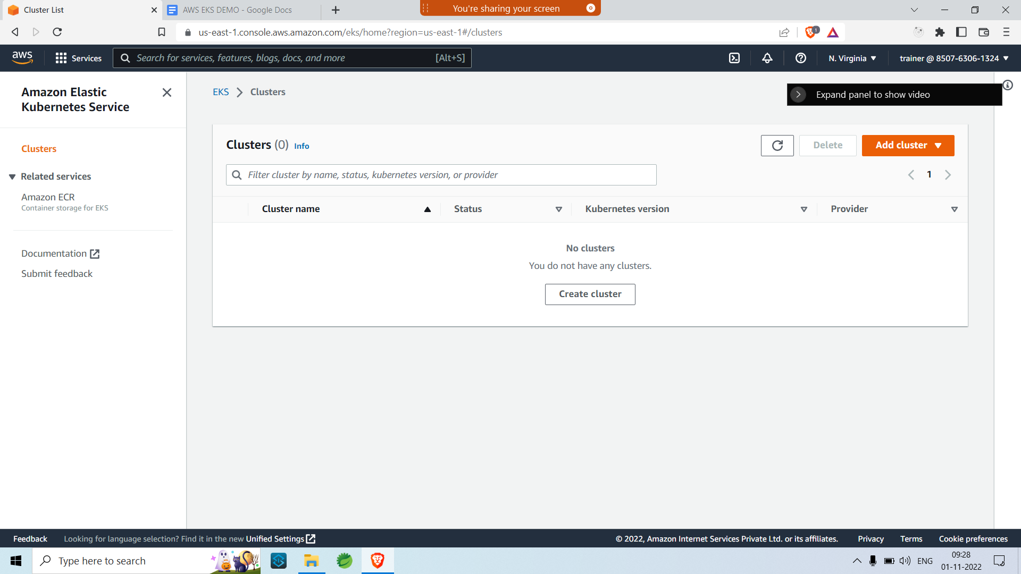

* Add cluster configuration
* Use existing EKS role if there is no role available follow the guide to create a role using IAM

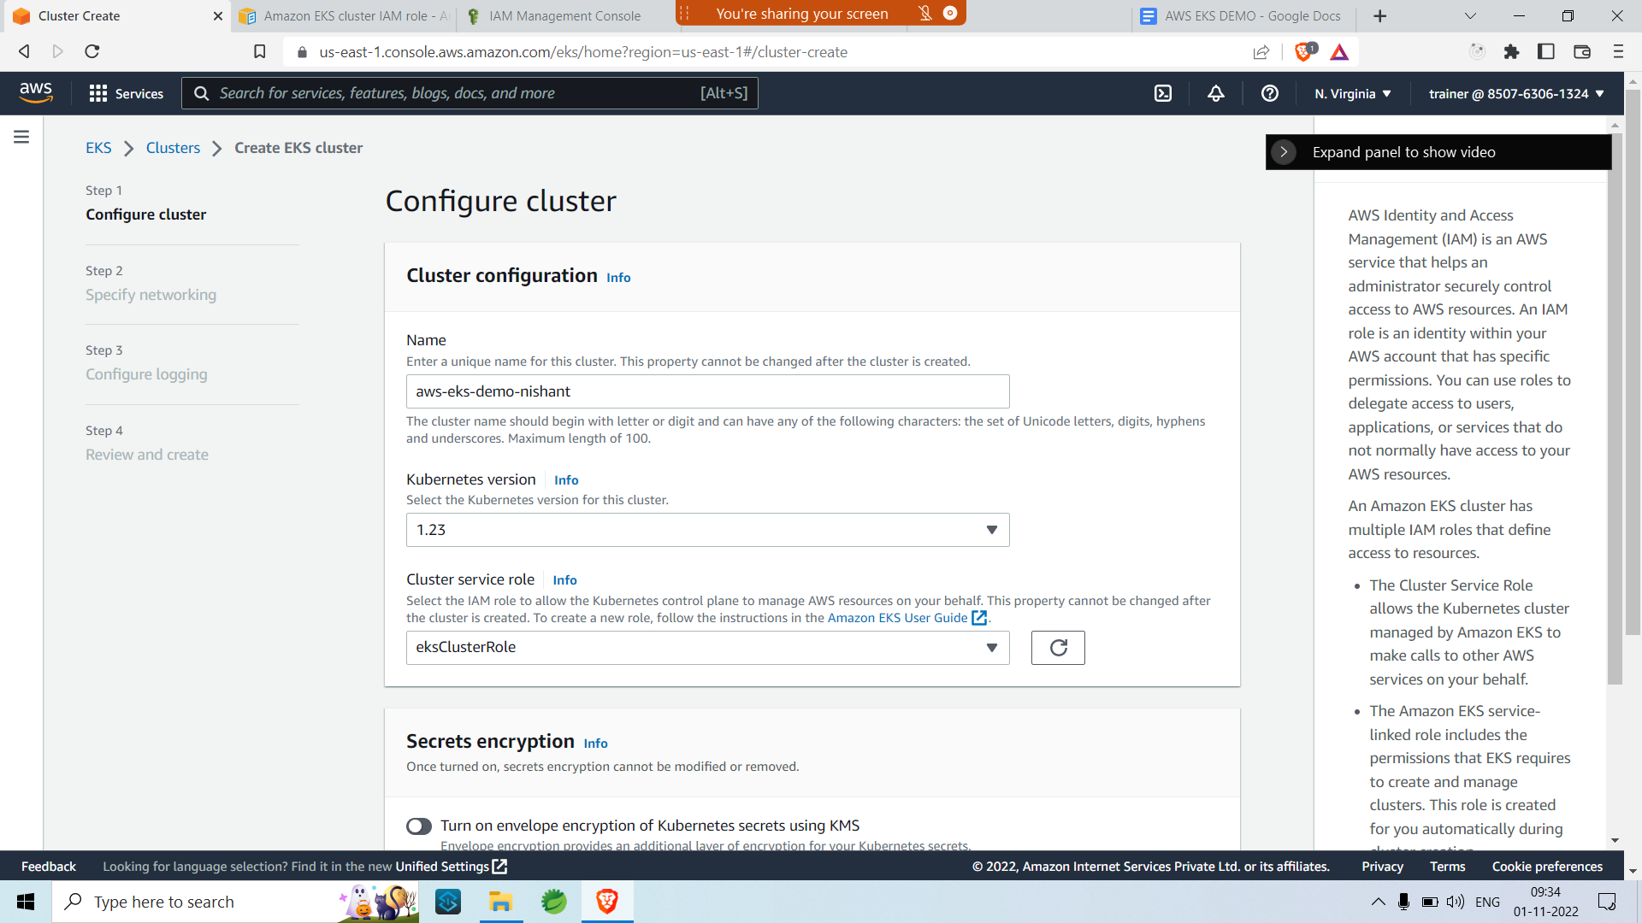

* Click on next , don’t add encryption or any tags.
* Configure the network properties

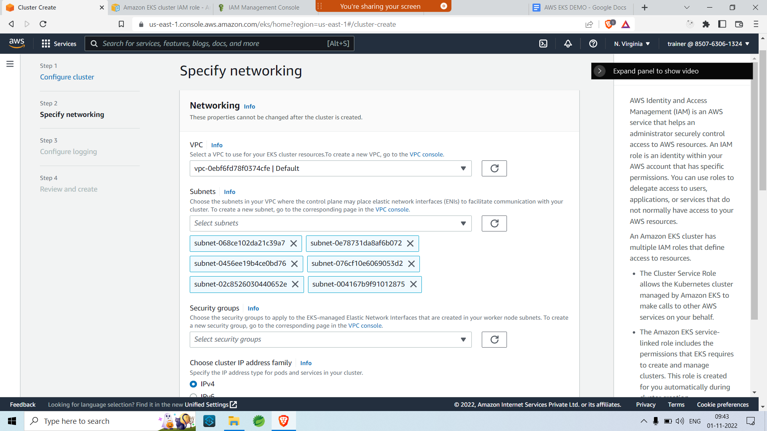

* Choose the Default VPC for this example( we are configuring the master node )
* Keep cluster endpoint as public and leave the rest of the configurations in their default state.
* Click on next.
* Select any log if you wish to read any on Cloudwatch else click on next.
* Review the whole and create

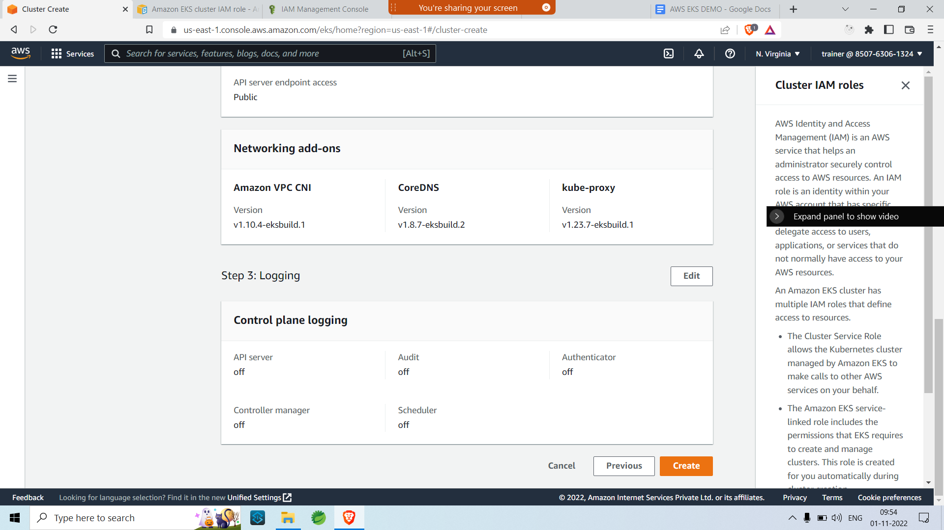

* If you do get any errors uncheck us east 1 e from the subnets
* The click on create again.

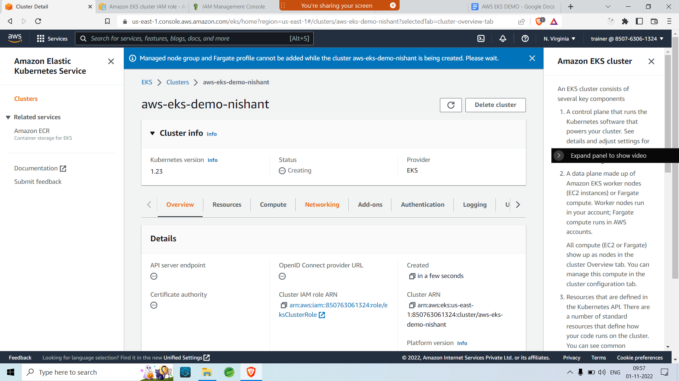

Step 2:-

Installing Kubectl to connect to EKS dashboard

* Go to AWS user guid and follow the url <https://docs.aws.amazon.com/eks/latest/userguide/install-kubectl.html> for Kubectl installation guide
* Once Kubectl is installed and the path is set.
* Check the version by running,
* **kubectl version --short --client**
* To verify the installation.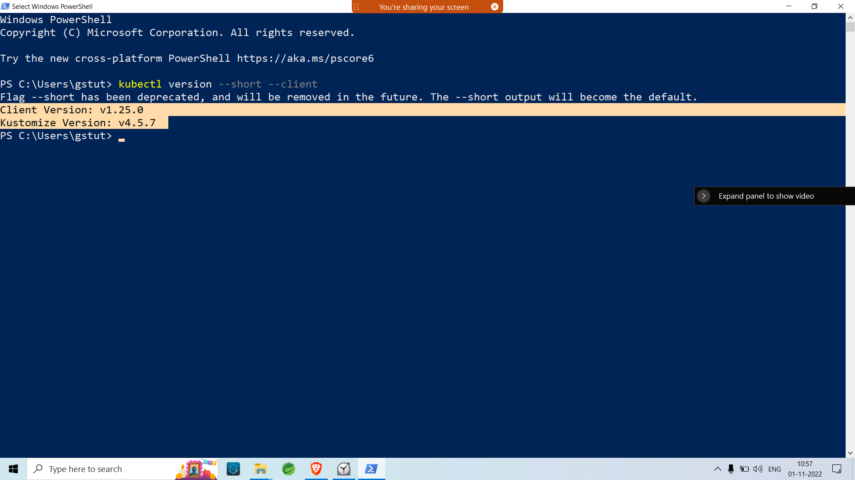

Step 3:

Check Cluster status using Kubectl utility

* Open powershell window
* Log in to your AWS CLi by running **AWS configure.**
* If AWS CLI is not installed in your system you can follow the steps and install it from the link below ,
* https://docs.aws.amazon.com/cli/v1/userguide/install-windows.html#awscli-install-windows-path
* Passing your AWS access id and AWS access key.
* The run
* **aws eks --region us-east-1 describe-cluster --name aws-eks-demo-nishant --query cluster.status**

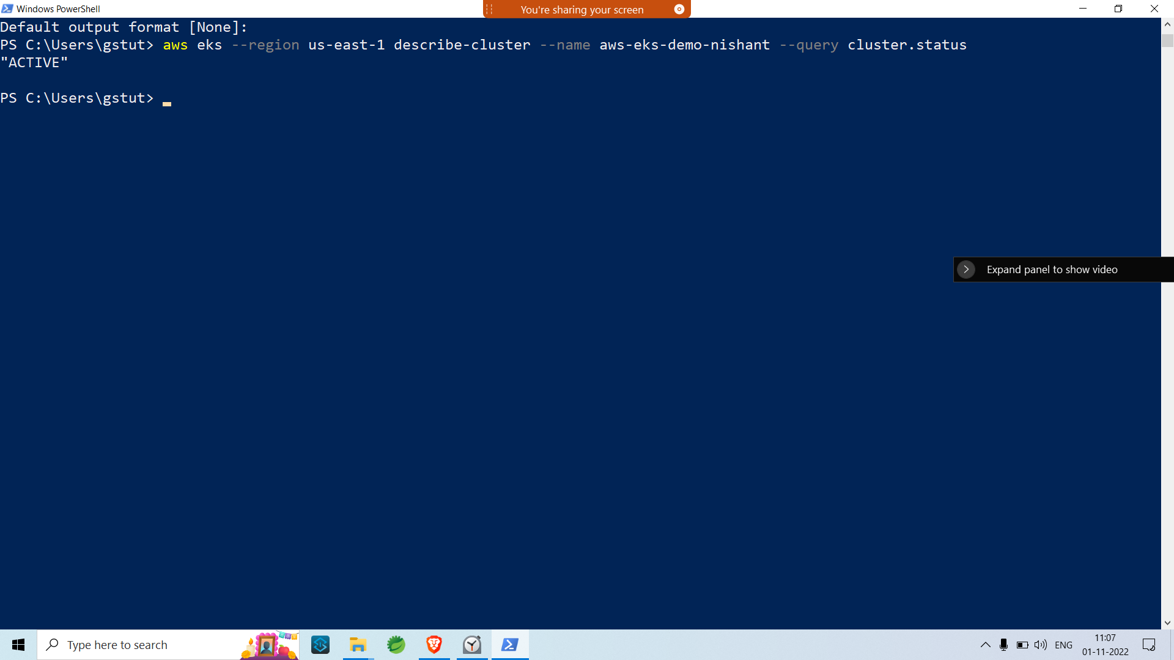

* Add the config context to the local system bu running
* **aws eks --region us-east-1 update-kubeconfig --name aws-eks-demo-nishant**
* And the run  **kubectl get svc**  to get the CLuster info
* If you encounter an error
* invalid apiVersion "client.authentication.k8s.io/v1alpha1"
* Refer to <https://yaniv-bhemo.medium.com/fix-invalid-apiversion-client-authentication-k8s-io-v1alpha1-194b16b7ce90>

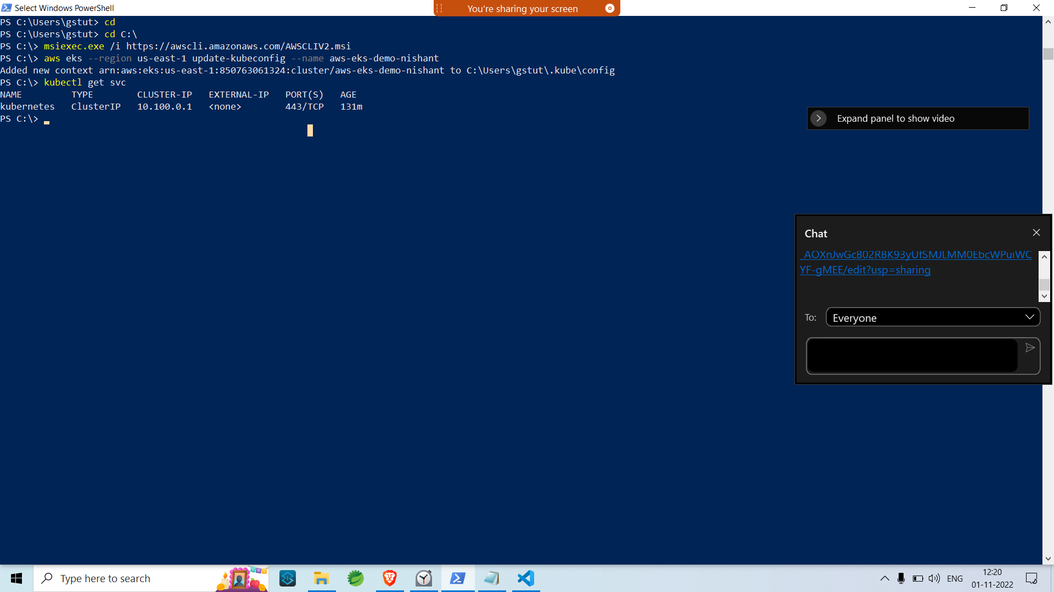

* We have successfully covered the master node.

Step 4: Configuring the Slave node .